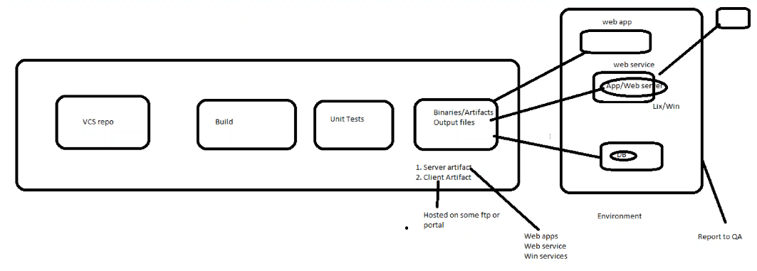

**There are two types of binaries**

1. Server artifact
2. Client artifact

* Client artifact is simple, we just need to generate and host on some portal, then the clients will download it and start using it
* Server artifacts are webapps, webservices
* These we need to host on server. To do that, we need an application. The physical server might be a linux or windows etc. on top of that, web application cannot run directly, we need to host an app/web server on top of that, we need to deploy our application. Then only clients can access from their browsers
* Webapp is a frontend and webservice is backend to get the data
* The application running and working fine after deployment. All as usual, it is called environment
* Our job is to deploy it and if its running fine, need to inform QA team to test

**Prior knowledge:**

* Application
* App/web server knowledge
* DB
* Web server is used to serve the static content
* But app server is used to serve the static and dynamic content

**App servers**: apache tomcat, web logic, web sphere, glash fish, jetty etc… where we can host war files

**Web servers:** we host it for static content like images, videos, text files etc… apache, httpd/ & ngnix servers are available for this

* Both work on http/https protocol

**Tomcat Introduction:**

* It is an application server. It is java-based application and supports java applications.
* Web servers are for static websites and app servers are for dynamic websites.
* Application servers can handle more load than web servers.

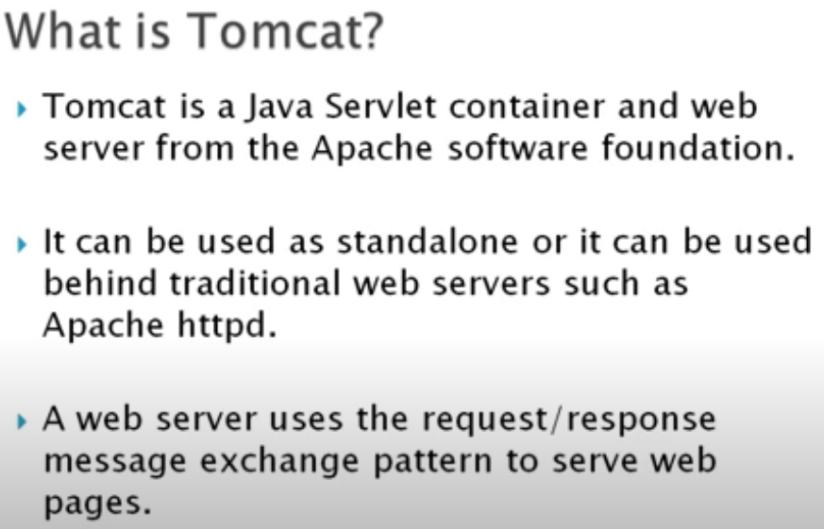

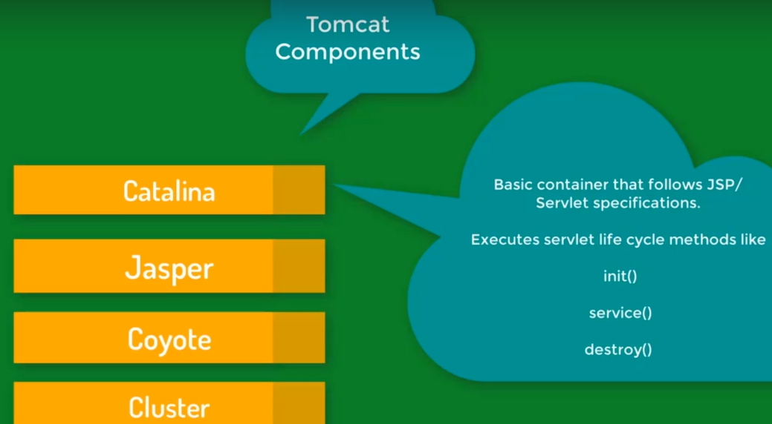

* The whole tomcat functionality is managed by the above 4 components.
* The Catalina is a core component of tomcat that handles the servlets.
* Jasper convers the JSPs to servlets.

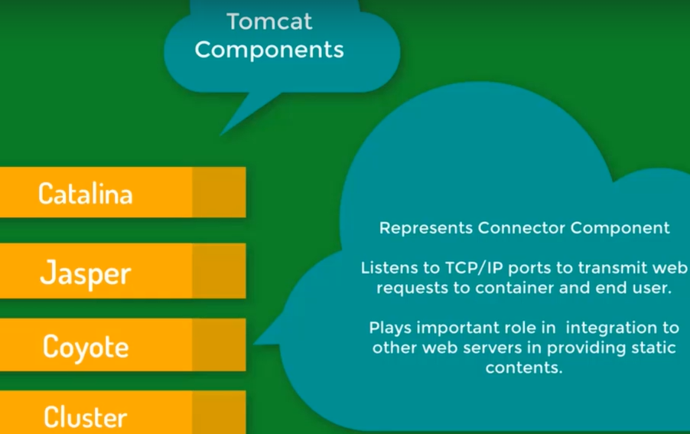

* Coyote is responsible for connection request. It also helps to integrate another web server with tomcat. It also plays major role while running SSL.

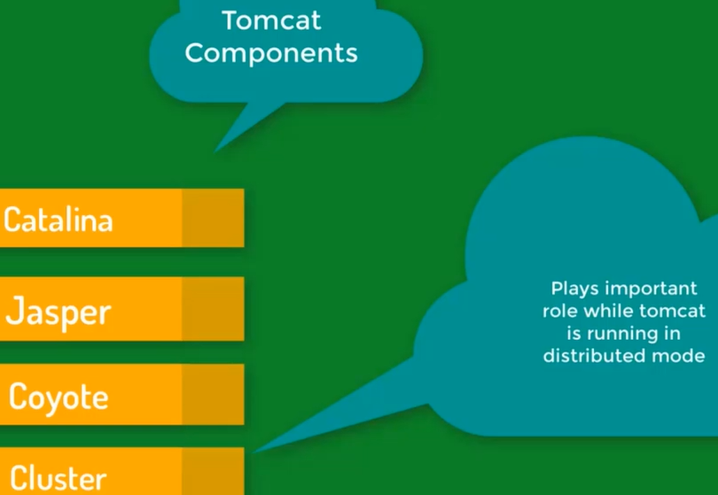

* Cluster is basically a load balancer that helps in distributing the work for large scale applications.

**Installation:**

* We should have java installed. Below command to install jdk
* **sudo yum install java-1.8.0-openjdk.x86_64**
* set java home location



* Download the tomcat by using the below command
* **Sudo yum install wget (to install wget)**
* **Wget <url>**
* **Sudo tar -zxvf apache-tomcat-8.0.52.tar.gz (to extract the file)**
* Go to bin directory, then run ./startup.sh. with this, we can start tomcat server
* By default, tomcat has 8080 port number. If we have Jenkins installed already, we may can’t access tomcat
* So, go to logs directory and check Cataline. Out file
* We can have a look at these logs if there is something wrong
* We can see an exception saying that the address is already in use. As because Jenkins is using the same port



* So, we need to change the port

**Installation using yum:**

